FINAL PROJECT - REPORT 3

PROJECT NAME : CTU: Toronto

PROJECT MEMBERS : Peter Vuong & Melody Leung

Programme Outline:

CTU: Toronto is a simulated role playing game. This role playing game allows the user to take on the role of an intelligence officer, working concurrently with an experienced intelligence officer Jack Bauer, to prevent possible terror attacks. The user will be will be working through various missions to unlock clues that will identify the mastermind of the possible terror attacks. Please note that additions, removal, or enhancements of the below screens will be at the sole discretion of the Team.

Programme Screenshots:

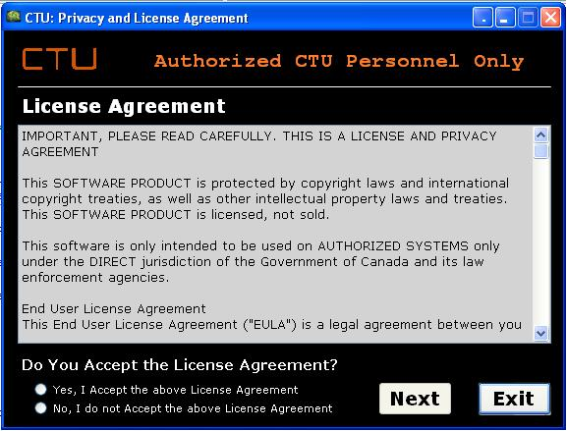
Figure 1: Privacy and License agreement screen; contains information about various terms and conditions.
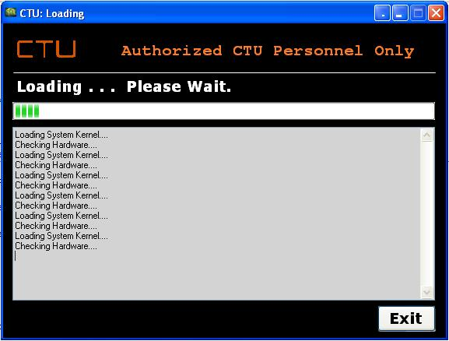
Figure 2: Loading screen; simulating connections to local and national law enforcement agencies.

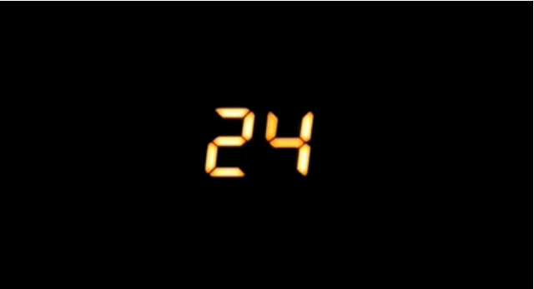
Figure 3: Splash Screen; in a form of a video animation.

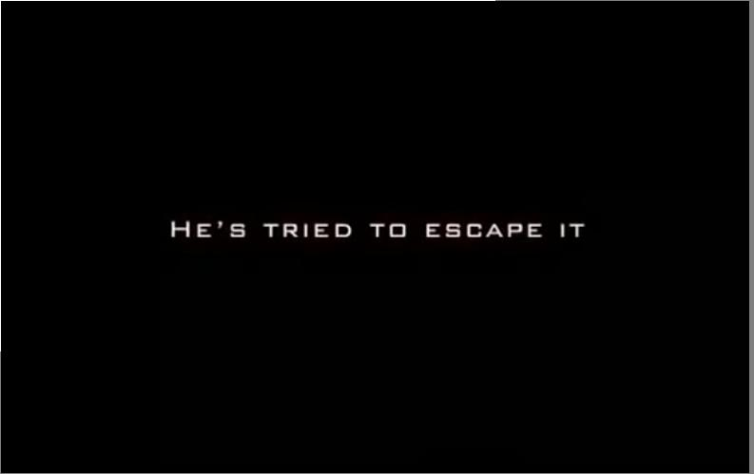
Figure 4: Trailer Video; provides an outline of what the game’s storyline will be about and what situation the player will be facing.

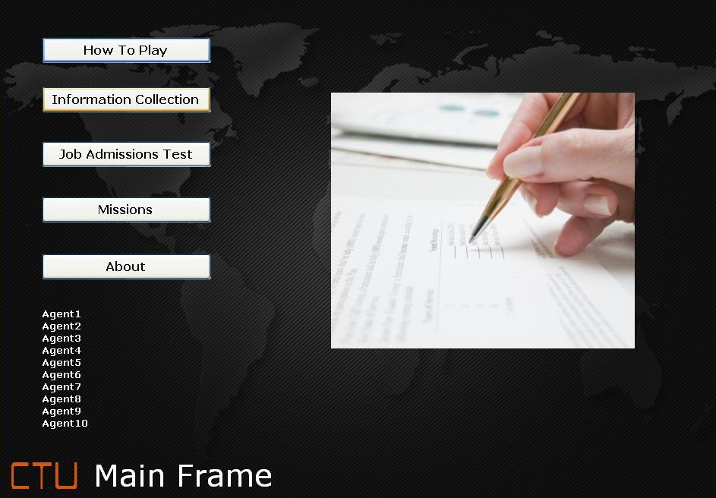
Figure 5: Main Frame form; the central location of all aspects of our program.

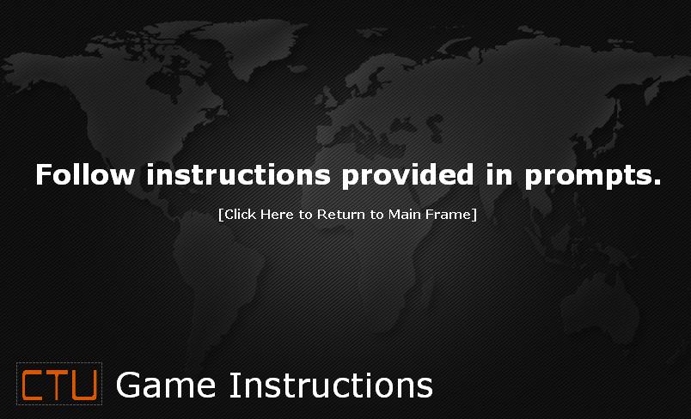
Figure 6: Game Instructions screen; provides game specific instructions to the user.

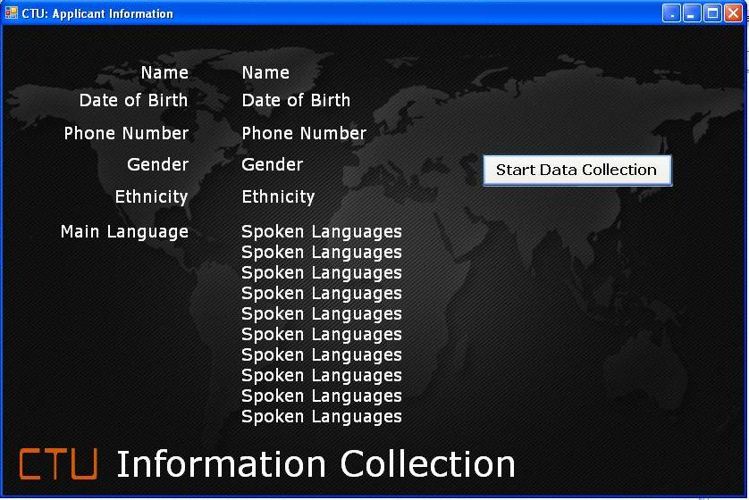
Figure 7: Information Collection screen; collects information about the user.

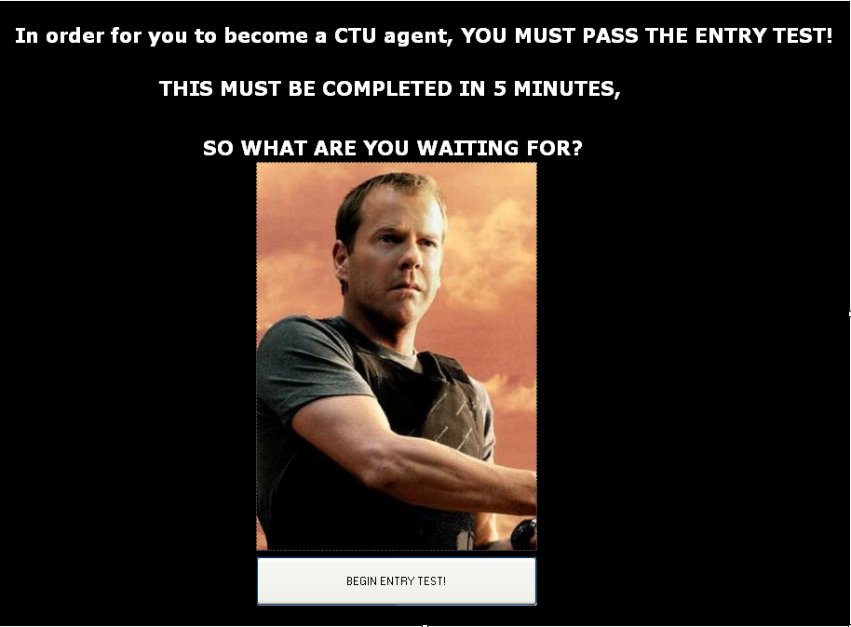
Figure 8(a): Job Admission Test; consists of basic skill testing questions and the ability to follow instructions.

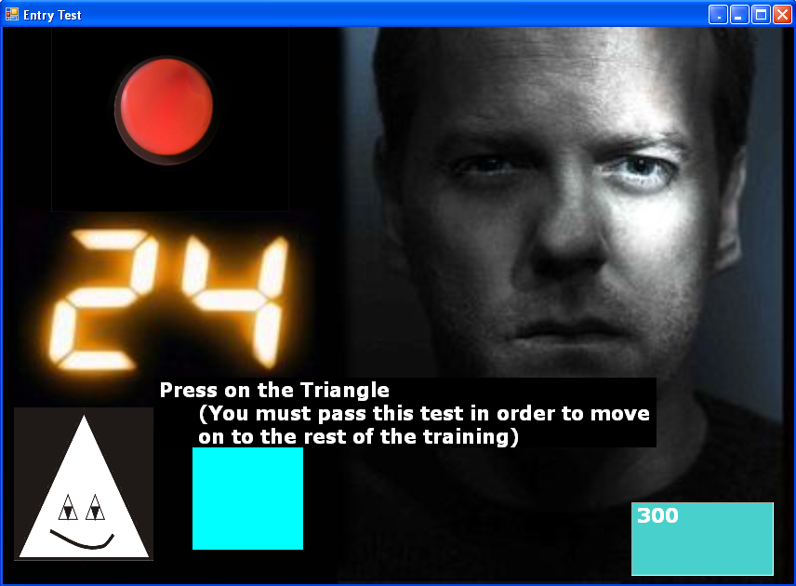
Figure 8(b): Job Admission Test; consists of basic skill testing questions and the ability to follow instructions. (Click in Triangle)

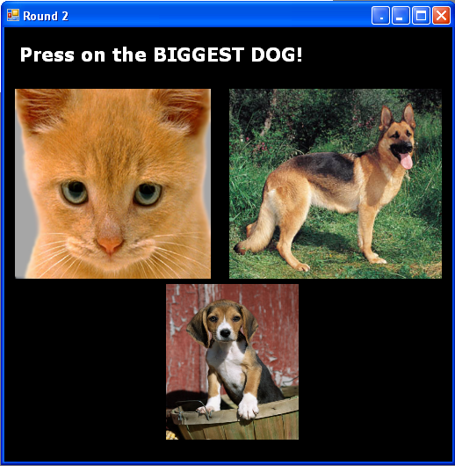
Figure 8(c): Job Admission Test; consists of basic skill testing questions and the ability to follow instructions. (Click on the image in the top right hand corner)

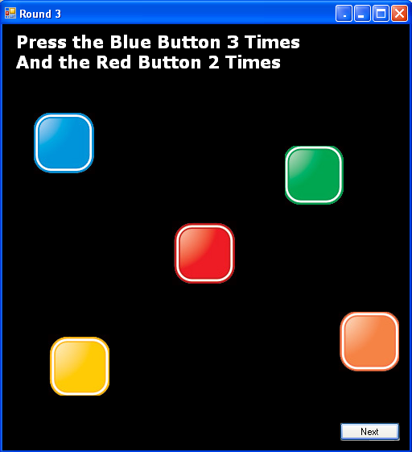
Figure 8(d): Job Admission Test; consists of basic skill testing questions and the ability to follow instructions.

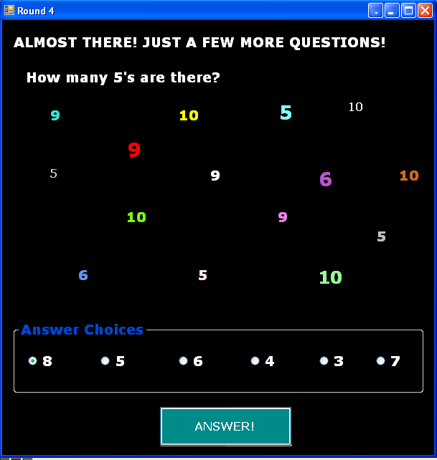
Figure 8(e): Job Admission Test; consists of basic skill testing questions and the ability to follow instructions. (Select “5”)
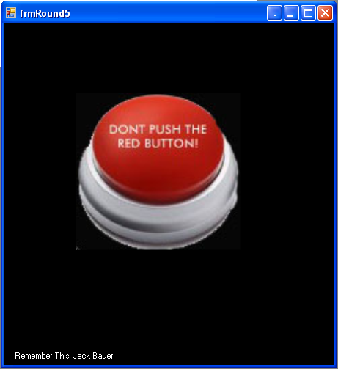
Figure 8(f): Job Admission Test; consists of basic skill testing questions and the ability to follow instructions. (Click on the “black” area)

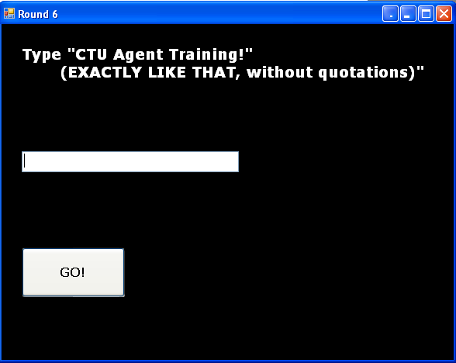
Figure 8(g): Job Admission Test; consists of basic skill testing questions and the ability to follow instructions. (Type in “CTU Agent Training!” Note: Do not forget the ! sign)

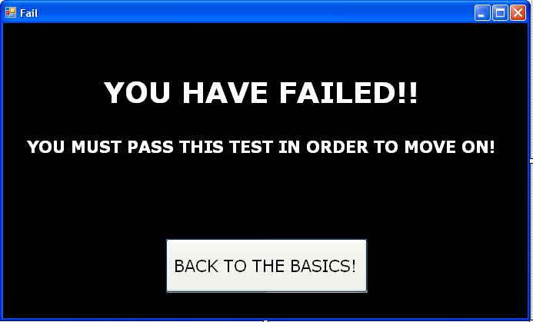
Figure 8(h): Job Admission Test; consists of basic skill testing questions and the ability to follow instructions. (If at any point you do not follow the instructions, you fail and must click “Back To The Basics” to start over again.)

Figure 8(i): Job Admission Test; consists of basic skill testing questions and the ability to follow instructions. This screen will show if the user has passed the admissions test.

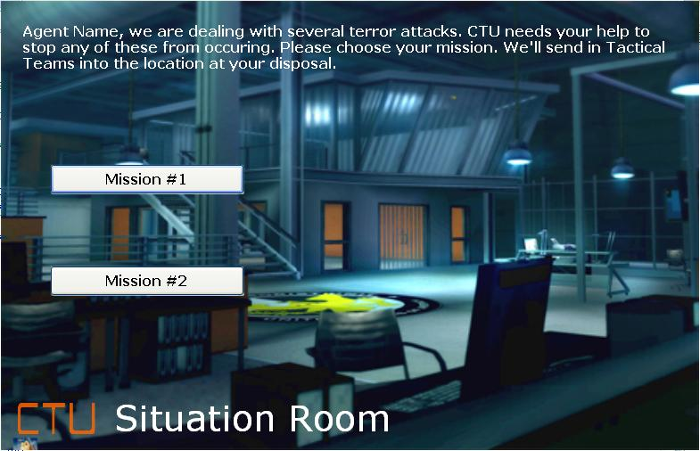
Figure 9: Situation Room screen; displays the missions the user must complete in order to unlock clues about the mastermind of the terror attacks.

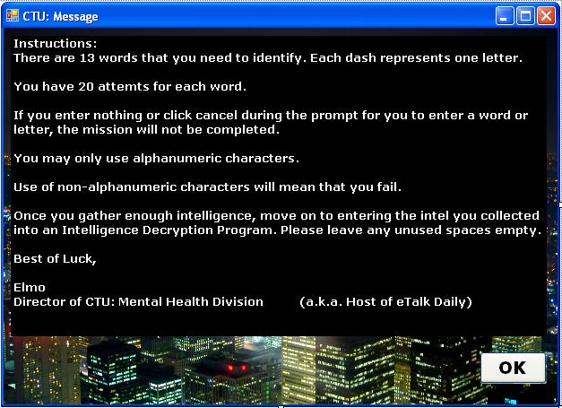
Figure 10: Message; Outlines what the user has to do in this mission.

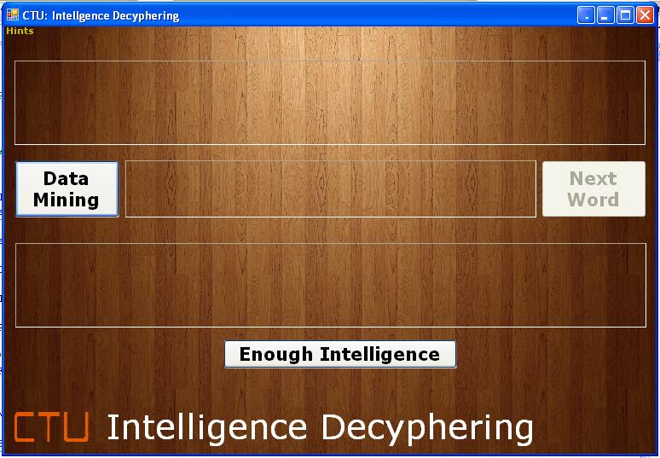
Figure 11: Intelligence Deciphering screen; this is where the user gathers information on about the location the terror attack will be taking place.

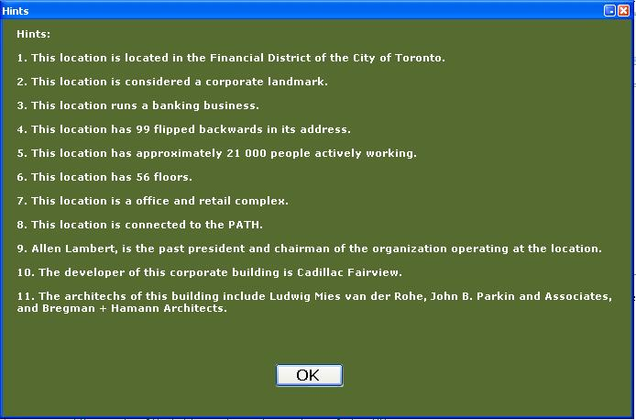
Figure 12: Hints screen for Intelligence Deciphering; this is where the user gets 11 hints on where the attack will take place.
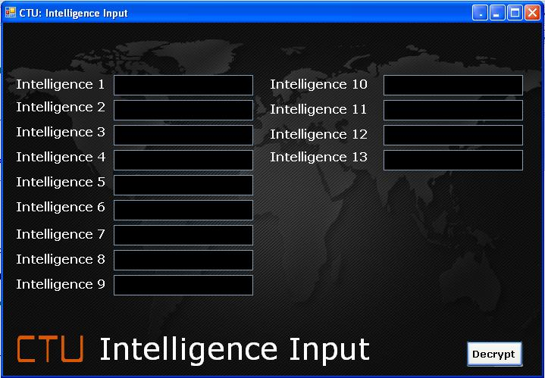
Figure 13: Intelligence Input; this is where the user enters the words they have deciphered earlier.
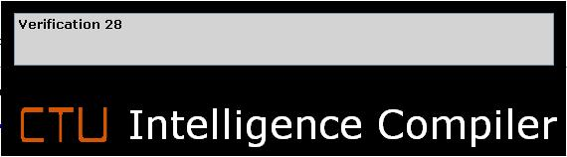
Figure 14: Intelligence Compiler; this is a simulated loading screen. It will simulate the compilation of the intelligence inputted earlier.

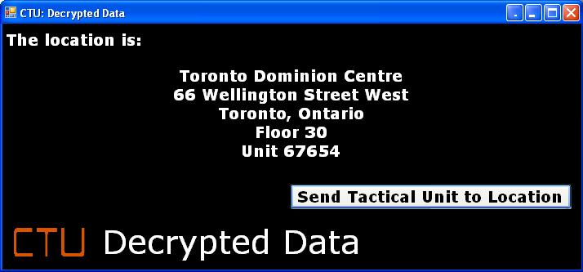
Figure 15: Decrypted Data; displays the location of the possible terror attack will be taking place.

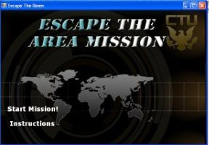
Figure 16: Escape the Room Mission

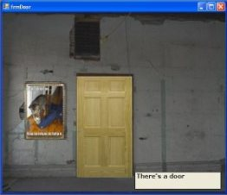
Figure 17: This is one of the screens in the room.

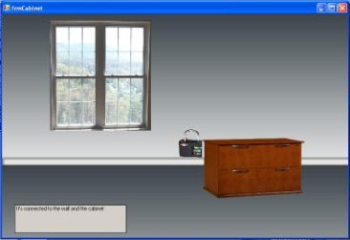
Figure 18: This is another screen while the user is in the room.

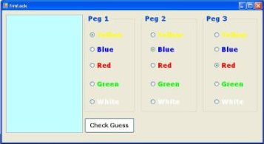
Figure 19: Mastermind; this will be activated when the lock is clicked.

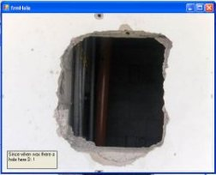
Figure 20: Hole; this hole is behind the cabinet.

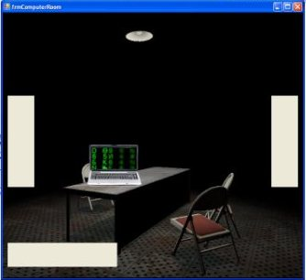
Figure 21: Computer Room; the user will complete other tasks by clicking the computer.

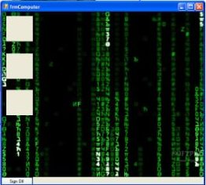
Figure 22: This is the computer screen.

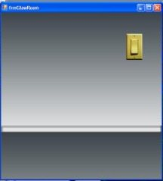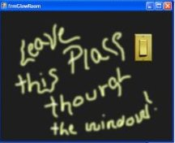
Figure 23: Clicking the switch will illuminate a clue to show you how to leave the area.

Figure 24: This screen will have the user match pictures; a mini-game within the Escape the Room Mission.

Figure 25: This screen is an image of the maze; a mini-game within the Escape the Room Mission.

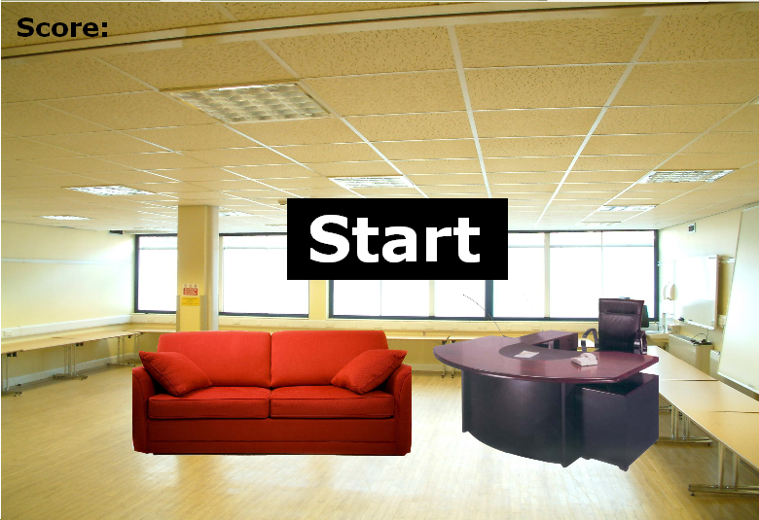
Figure 26: Shooting Accuracy; user will have to shoot combatants as they appear and maintain a certain score.

